EXPERIMENT 5

AIM: Simulation of Gas Leakage Detection Project on TinkerCad.

THEORY:
- Gas leakage, especially from LPG (Liquefied Petroleum Gas), natural gas, and hydrogen, is a critical safety concern in both residential and industrial environments.
- These gases are highly flammable and potentially explosive when present in certain concentrations. Detecting such leaks at an early stage is essential for preventing accidents, property damage, and loss of life.

Working Principle
The MQ5 sensor operates based on a SnO₂ (tin dioxide) sensing layer, which has lower conductivity in clean air. When flammable gases such as LPG or methane are present, the conductivity of the sensor increases. This change is converted into an analog voltage output (0–5V), which is proportional to the gas concentration in ppm (parts per million).
The Arduino Uno reads this analog signal via its A0 pin, processes it, and compares it against a pre-set threshold value (e.g., analog value of 300 ≈ 1000 ppm).
If the sensor output exceeds this threshold, the Arduino outputs a HIGH signal to a digital pin (e.g., D13), which lights up an LED to indicate gas leakage. If the gas level is within safe limits, the LED remains OFF.

Simulation Output
When simulated using platforms like Tinkercad, Proteus, or via the Arduino IDE serial monitor, the system behaves as follows:

OUTPUT:

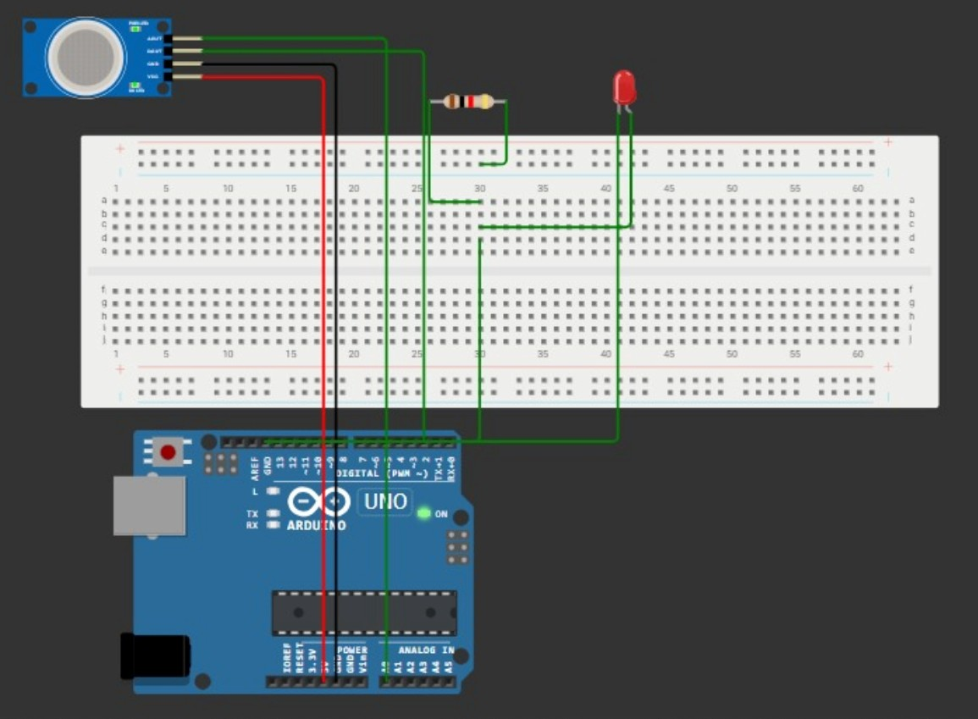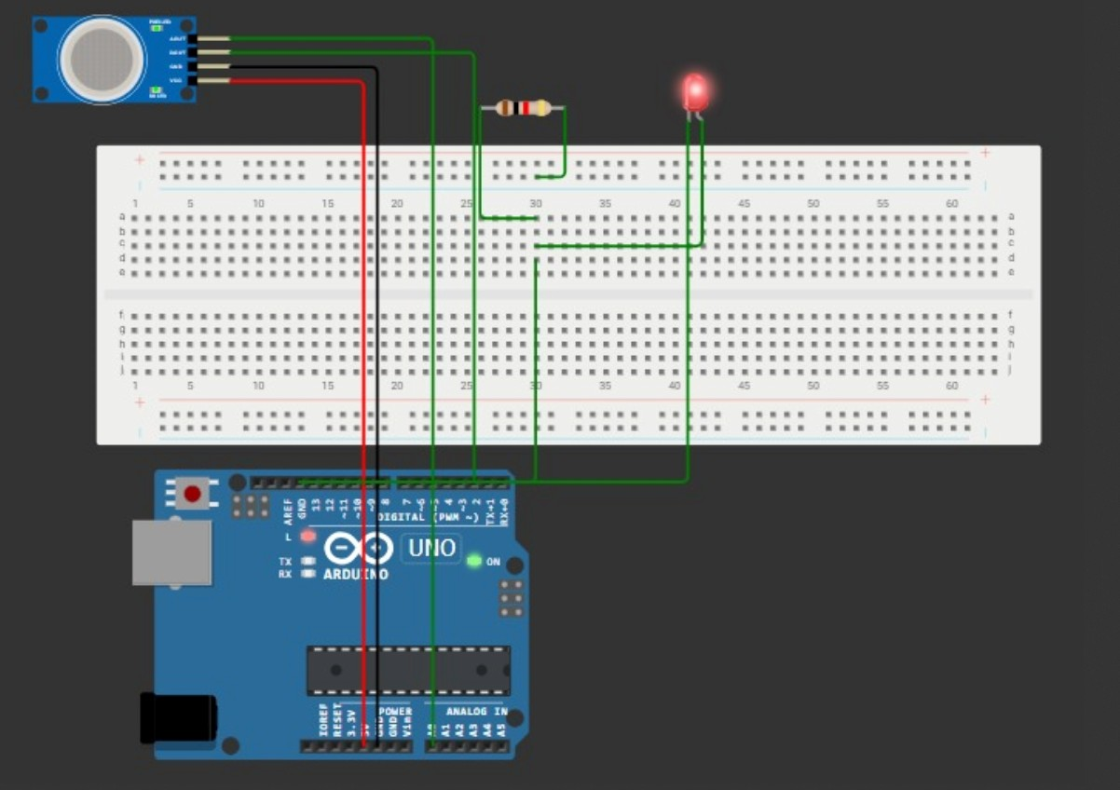

CONCLUSION:
The simulation of the gas leakage detection system successfully demonstrates the core functionality of monitoring flammable gas concentrations using an MQ5 gas sensor and responding through a visual indicator (LED) using Arduino Uno.
Through this experiment, we have:
- Validated the responsiveness of the MQ5 sensor to changing gas concentrations.

- Demonstrated real-time monitoring capabilities using microcontrollers.

- Successfully simulated a visual alert mechanism triggered by unsafe gas levels.

